Chapter 8 Homework (Tables) - Web Development Technologies

In your html-css\homework\ch08 Homework folder
code the html and css from each image below.
a. Create table1.html and table-styles1.css Code the html and css from the image below.
i. Table Headings
ii. Background colors
iii. Text alignment
iv. Data in cells
v. Table border(s)
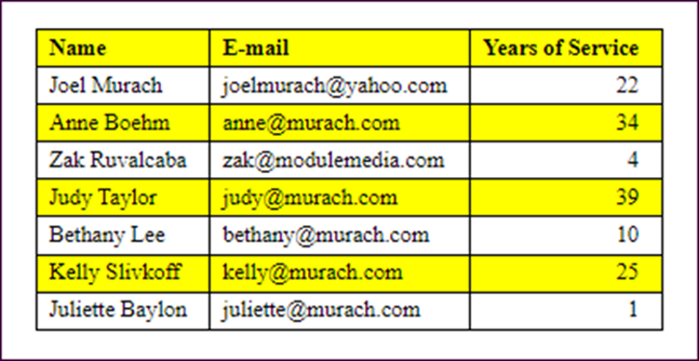
Table 1
b. Create table2.html and table-styles2.css Code the html and css from the image below.
i. Table Headings
ii. Background colors
iii. Text alignment
iv. Data in cells
v. Table border(s)
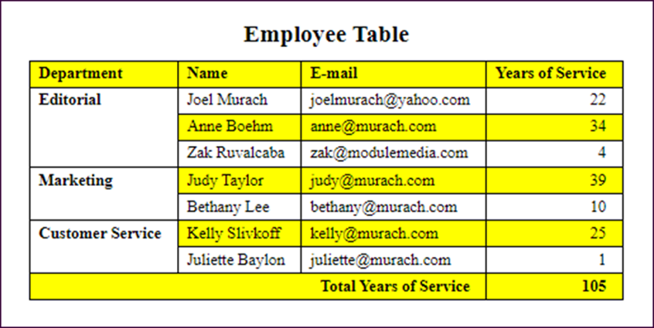
Table 2

